Group Contributions Form
Group: GroupNo6
Team Mate  (Name) | Contributions to Team. | Commendations | Percentage of overall contribution
Edward Hadnett |  |  | ?/100
Marc Jones | Wireframes  Site flow mapping  ‘Jumper’ mini game  AI integration through Ollama  Question input/output handling  Question JSON editor  Group organisation  Client correspondence  Meeting minute tracking  Project proposal | I would like to congratulate and thank my whole team for maintaining open and helpful communication throughout the project.  In particular, Aarju did a great job at creating almost all the frontend of the website. Ranging from designs, site traversal and interaction. Also for handling a lot of the firebase setup and interaction.  I also think Edward did a good job at providing the mini games for the game loop. | ?/100
Aarju Shrestha |  |  | ?/100
Nicholai Baes |  |  | ?/100
All group members agree to acknowledge the above contributions. (Yes/No)
*We understand that if we answered No to the above, we will be called for a viva with the Module Leader to mediate the dispute. Module Leader will have final decision on the contribution %.

Signatures
Edward Hadnett
Marc Jones | 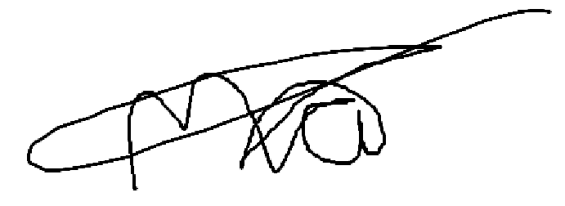
Aarju Shrestha
Nicholai Baes

Discuss contributions to analysis, design and documentation, contributions to solution implementation, contributions to LSEP, and any other significant contributions. Below the claim, highlight where in the report/git/Trello/reflection where we can find evidence for the claim.

